D.Y.PATIL COLLEGE OF ENGINEERING &TECHNOLOGY,
KASABA BAWADA, KOLHAPUR
DEPARTMENT OF COMPUTER SCIENCE & ENGINEERING
(Academic Year: 2024-25)

SYNOPSIS
On
Domain Specific Mini Project
Project Entitled
As
Sign language Detection System
Submitted By:
Roll No. Name
29 Ankit Chandrakant Bhosale
31 Harsh Ramesh Parab
34 Vikrant Narayan Kamble
35 Jyotiraditya Prakash Chavan

Under the Guidance of:
Prof. Mr. T. V. Salokhe
Class: TY (CSE) Div.: “A” Batch: T2.
Abstract:
The " Sign language Detection System" aims to leverage technology to enhance cognitive skills in children with diverse disabilities. This program is designed to provide an engaging, interactive, and personalized learning experience that can be accessed from the comfort of home. Utilizing a combination of gamified exercises, adaptive learning algorithms, and real-time feedback, the program targets key cognitive domains such as attention, memory, problem-solving, and executive functioning.

Research indicates that early intervention and consistent practice can significantly improve cognitive abilities in children with disabilities. However, access to specialized training programs is often limited due to geographical and financial constraints. Our computerized platform addresses these challenges by offering a scalable solution that empowers parents and caregivers to facilitate cognitive development at home.

The program includes a variety of modules tailored to individual needs, allowing for customization based on each child's specific strengths and weaknesses. Progress tracking features enable caregivers to monitor improvements over time, fostering a collaborative approach between parents and healthcare professionals.

By integrating evidence-based cognitive strategies with modern technology, this initiative aims to create an inclusive environment that promotes the cognitive growth of children with disabilities, ultimately enhancing their quality of life and independence. The findings from this project may serve as a foundation for future research and development in the field of assistive technology for cognitive training.

- Introduction

Children with disabilities often encounter barriers to accessing effective cognitive retraining programs, hindering their ability to develop crucial cognitive skills essential for daily functioning and social interaction. Among these children, those who rely on sign language face unique challenges in engaging with traditional cognitive training methods, which often lack accommodations for their communication needs.
In response to these challenges, there is a growing recognition of the importance of developing innovative solutions that not only address the cognitive needs of children with disabilities but also cater to their diverse communication preferences. One such solution is the integration of a Sign Language Detection program into Computerized Cognitive Retraining Programs (CCRP), designed specifically for home training environments.

- Problem statement:
The problem at hand necessitates the exploration of strategies to enhance the accessibility and inclusivity of cognitive retraining programs for children with disabilities, particularly those who rely on sign language as their primary mode of communication. Addressing this problem requires the development of tailored interventions that accommodate diverse communication needs and foster meaningful engagement, thereby promoting optimal cognitive development and well-being among children with disabilities.

- Objectives:

Assessment of Communication Barriers:

Identify specific communication challenges faced by children with disabilities, especially those relying on sign language, within existing cognitive retraining programs.

Development of User-Friendly CCRP:

Create a Computerized Cognitive Retraining Program (CCRP) tailored to the cognitive abilities and needs of children with disabilities, emphasizing accommodation for diverse communication preferences, including sign language.

Creation of Sign Language Detection Program:

Develop a Sign Language Detection Program capable of accurately recognizing and interpreting sign language gestures in real-time to facilitate seamless communication between children with disabilities and the CCRP platform.

Impact Evaluation:

Evaluate the impact of the integrated CCRP and Sign Language Detection Web App on cognitive skills, communication abilities, engagement levels, and overall well-being of participating children with disabilities.

Exploration of Scalability and Sustainability:

Explore strategies for scaling up and sustaining the integrated CCRP and Sign Language Detection Web App, including potential dissemination and adoption in home training environments and educational settings catering to children with disabilities.

- Proposed system architecture:
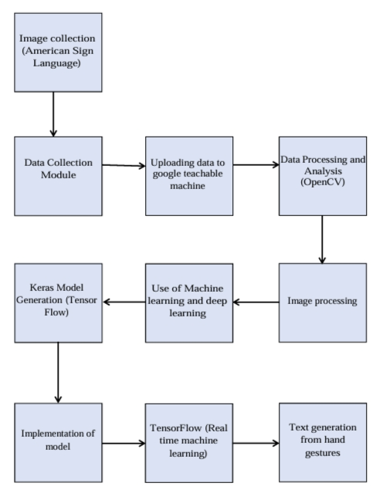
Added into list
Generates bill

Fig1. News App System Architectur

QR Code Scan

Modules :
1. Data Collection Module: Use of OpenCV – cvzone.handtracking module for data collection.

2. Media pipe module: Use of mediapipe for image capturing with its matrices.

3. Google Teachable Machine: Upload data model for model generation.

4. ML and DL: Learning of data and getting insights creating the data module (Keras module)

5. TensorFlow: Real time machine learning. 6. User Interface Module: Text generation from the user’s hand gestures.

System Requirements:

Hardware Requirements:

Processor: Multi-core processor with adequate processing power.

Memory (RAM): Sufficient RAM for data processing and analysis.

Storage: High-capacity storage for storing historical data and analysis results.

Graphics Processing Unit: dedicated graphics unit for smooth operation.

b.Software Requirements:

Operating System: Compatibility with major operating systems (Windows, Linux, etc.).

Pyhton: Use of Python is essential for this project.

TensorFlow: Use of TensorFlow For ML and DL.

Conclusion:

This project presents a promising solution for supporting children with disabilities in their cognitive development. The computerized cognitive retraining program, designed for home training, provides a structured and engaging platform to enhance cognitive skills. This program empowers children and their families by:

* Increasing Accessibility: Bringing therapy into the home environment eliminates barriers of time, cost, and travel, making it readily available for families.
* Personalized Learning: The adaptive nature of the program allows for tailored sessions based on individual needs, ensuring effective and engaging learning.
* Enhancing Engagement: The interactive and gamified elements of the program foster motivation and engagement, promoting consistent participation and skill development.
* Empowering Families: The program equips families with tools and resources to support their child's cognitive growth, fostering a collaborative learning environment.

While this project demonstrates the potential of home-based cognitive retraining, further research and development are crucial. This includes:

* Comprehensive Evaluation: Conducting rigorous studies to assess the program's effectiveness across various disabilities and age groups.
* User Feedback Integration: Continuously gathering feedback from families and children to improve the program's user experience and efficacy.
* Collaboration with Professionals: Partnering with therapists and educators to integrate the program into existing intervention strategies.

Ultimately, this project paves the way for a future where home-based cognitive retraining empowers children with disabilities to achieve their full potential, fostering inclusivity and unlocking their individual capabilities.

